**­­­**

Class 7

**Lecture 4**

**Basic Programming**

**Conditional Logic**

**Programming**

**&**

**Algorithm**

**Lab Objectives:**

* What is Conditional Statement?
* Several Types of Statement.
* What is Function and how it works?
* What is Loop? How it works?

**What is Conditional Statement?**

Conditional Statement is a statement upon which we can take decisions. When we talk about conditional statement in programming or real life, The first things comes in our mind is IF, IF….ELSE.



**Conditional Statement**

Some type of operators is:

• if statement

• if- else statement

• if-else if- else statement

• switch statement

1. **If Statement**

If statement works like "If condition is met, then execute the task". It is used to compare things and take some action based on the comparison.

The action is executed only when If condition is true. See given example-

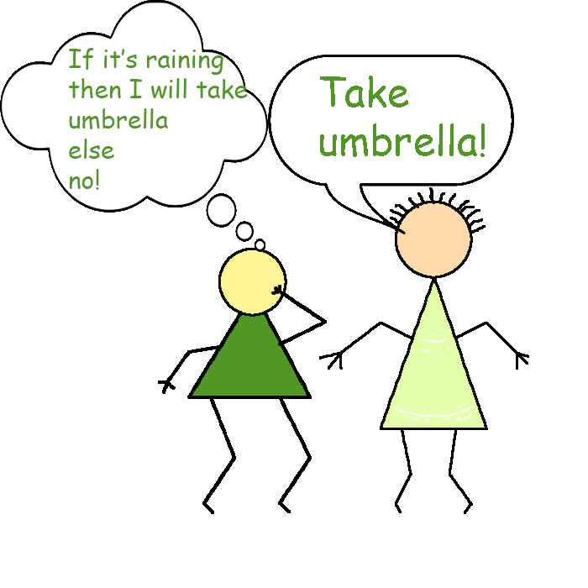

**Because It’s Raining!!**

1. **IF Else Statement**

This statement works like "If condition is met, then execute a specific task and If not met then execute another specific task". In this statement there should be two different tasks to execute based on the condition. One for TRUE and another for FALSE. If the condition become false, then the task of ELSE statement should be executed.



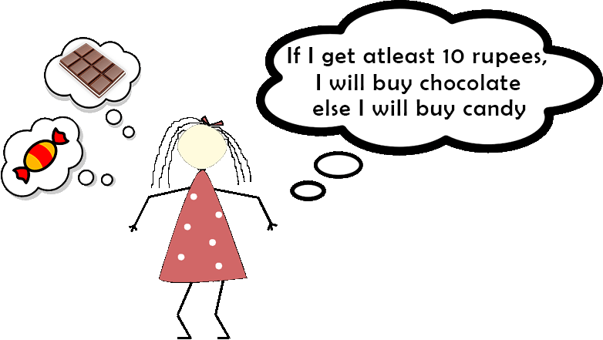

**TAKA**

1. **IF…Else If...Else Statement.**

The This Statement works like exactly the way If..Else statement does Except-Here can be multiple Else Condition which is represented by ‘Else If’.

**IF( Marks >= 90 ) THEN Grade = ‘A+’**

**Else IF( Marks >= 80 ) THEN Grade = ‘A’**

**Else IF( Marks >= 70 ) THEN Grade = ‘B’**

**Else IF( Marks >= 60 ) THEN Grade = ‘C’**

**Else IF( Marks >= 50 ) THEN Grade = ‘D’**

**Else Grade = ‘F’ (Fail)**

**Loop**

In computer programming, a loop is a sequence of instruction s that is continually repeated until a certain condition is reached.



1. **For Loop**

A for loop enables a particular set of conditions to be executed repeatedly until a condition is satisfied.

Imagine a situation where you would have to print numbers from 1 to 10. What would you do? Will you give instruction a hundred times or try to copy paste it? This simple task would take an eternity. Using a 'for loop' you can perform this action in 3 statements. This is the most basic example of the For loop.

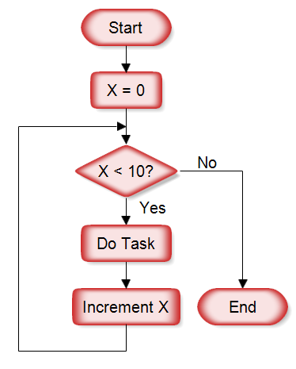

**Print X**